***Branching and Merging***

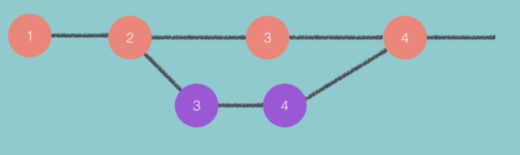

Purple are testing branches.

Open **story** file of **Version Control Using Git and the Command Line.**

**Create alient-plot branch**

**Syntax:**

**git branch <name>**

Search branch:

**git branch**

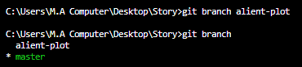

Asterisk shows that on which branch you are currently on.

**Switch to alient-plot**



Now inside this branch I want to switch to my chapters.

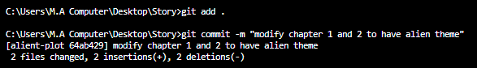

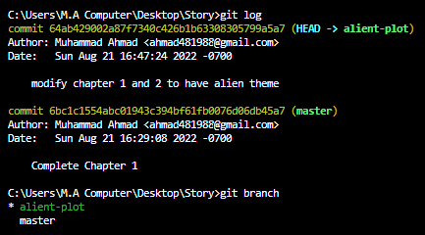

Go back to master



You can see that no changes in master branch as we changed text in alien branch.

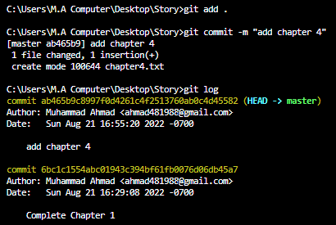

Let’s switch in branches



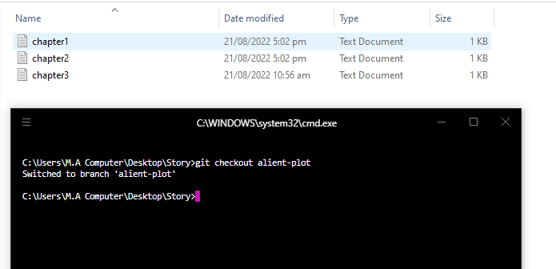

Note that inside alient-plot branch, there are 3 files.

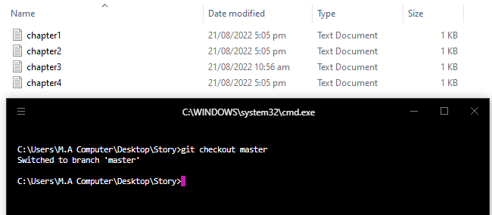

Note that inside master branch, there are 4 files.

Now we want to merge the changes inside the **alient-plot**

**Syntax:**

Git merge <branch name which you want to specify>

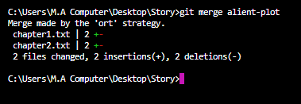

**:q!**



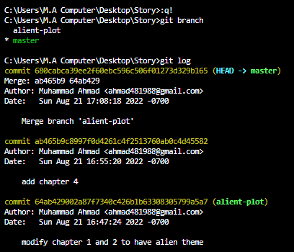

At this point push origin

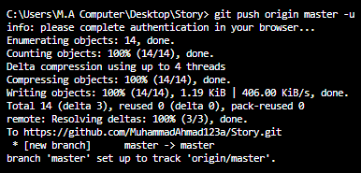

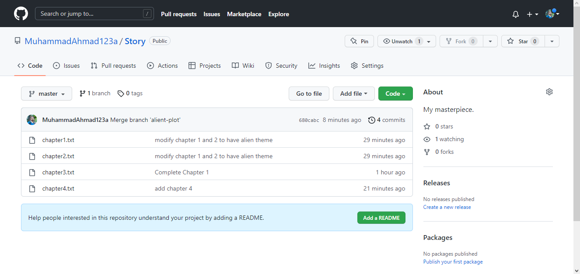

You can see that we make branches as it can be seen on git hub.

Let’s create a new repository 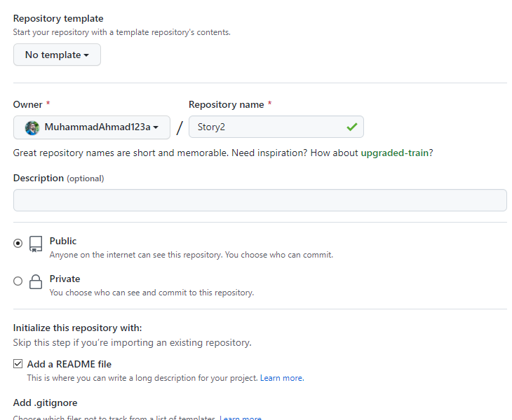

<https://github.com/MuhammadAhmad123a/Story2/>

Create a new chapter

Chapter2.txt

Text is **This is an even better chapter.**

and add commit **Create chapter 2** in **main branch.**

Now check insight graphs and inside structure.

Now go to **New pull request** this contains difference between main and local branches as we see in hyper terminal.

Now **create pull request** and create and merger branches

**Merge experimental to master.**

All is the same as we done in **hyper terminal**

